Accepted by the decision of Board on .................................

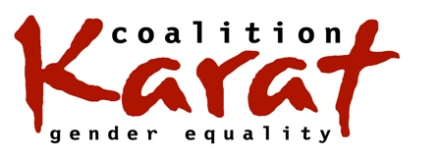 | MISSION  KARAT is a regional coalition of organisations and individuals focusing its action on observance of women’s human rights, and ensuring gendered economic and social justice in the Region.  Our Region is the territory of the Central and Eastern European and Central Asian countries.

Organisational membership form

Organization/institution: ...........................................................................................................................
.....................................................................................................................................................................
Date when it was founded: ……………………………………………………….......

Address:
Street: .....................................................................................................................
City: ..................................................... Postal Code: ............................................
Country: ..................................................................................................................
Telephone/fax: ........................................................................................................

E-mail: ....................................................................................................................
WWW: ....................................................................................................................

It was decided at/by (name the body)…………………….
on (date)……………………………
that the organization supports the mission of the KARAT Coalition
and would like to be a member.

CONTACT PERSONS: | FIRST PERSON | SECOND PERSON
First name:
Last name (surname):
Signature:
Phone:
E-mail:

______________________ ________________________
Date Signature of the responsible person

The membership form should be sent:
- by post to the address: KARAT Coalition, ul. Walecznych 26/5 03-916 Warsaw, Poland
OR
- by e-mail to the address: agnieszka.mazurek@karat.org.pl (the signed and scanned version)
OR
- by fax: +48 22 6282003 (the signed and scanned version).

